Digital Decay
In the second Witness essay for BLEED 2020, highly-online writer Asher Wolf explores how digital and physical realities bleed while taking a walk in an isolated forest during COVID-19. Please note this work contains references to s*lf harm.
I got some credit in the straight world
I lost a leg, I lost an eye
Go for credit in the real world you will die
It's the credit in the straight world
Leave your money when you die
Lots of credit in the real world gets you high
I got some credit in the straight world
I lost a leg, I lost an eye
Go for credit in the real world, you will die
– Hole
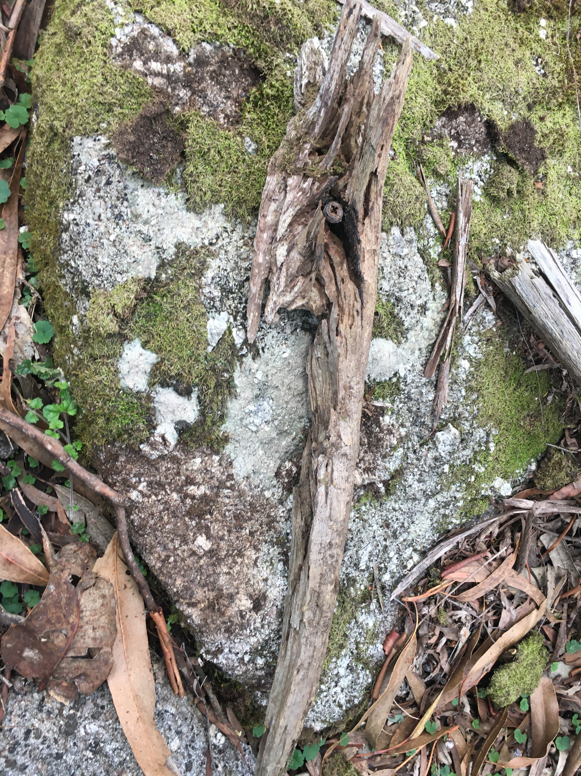
As a teen, to escape the nights punctuated by paternal violence and my mother’s silence, I used a pilfered hunting knife from my father’s hunting kit to cut my supple skin, seeking relief from overload of emotion. I cut until the distraction of a black screened Apple machine arrived in our home in 1994.
The modem sang to a world outside my suburban misery. Beyond the cuts I made on my skin, I left behind the wounds I inflicted upon myself and sank into whiling away my time in an online world.
The internet was a billion nerve endings all at once, growing around me as a teenager and a young adult. I grew with it, an internet thing with an internet army of internet followers, internet words for internet causes. It was a world of instant desires and relief, constant hordes of begging and cajoling – “please sign my petition, please promote my posts” – my spam folder always full of fraudulent swindles and pleading for donations for starving children in far off countries connected by high-speed internet.
I learnt how to exist within an internet carve-out, selling campaigns, issues and drama in an attention-driven market, seeking threats to snare people’s gaze, selling forecasts divined from 10 tabs open on a computer screen constantly scrolled for information, dodging posts on “how to make your penis grow 10 inches overnight” and “click here to speak to local girls”, moth to a light, watching and waiting for the right moment and method to speak, to churn content in the walled gardens of social media.
I wanted the world to want me to exist beyond the confines of my personal history of trauma. I spent a thousand sleepless nights scanning information and curating news, tweeting snippets of things I thought would hold people’s interests, fighting trolls, hiding under pseudonyms and VPNs. A citizen interloper in the war of the fifth domain, I gathered open source intelligence and harboured leaks, a stringer to an underfunded online journalism industry, staring into a dark screen, living in a world of closed curtains, planted into an ass-creased couch cushion, examining the minutiae of my own photo-shopped avatar and profile, spilling my words for dopamine dreams of a world beyond scrubbing dishes and hanging laundry, privately delighting at the insanity of 1058 unread messages signalling unmet demands for my attention. 17 hours a day online, to make myself feel alive.
“You want to do something worthwhile because you don’t think you’re enough, and so you spend all day online hoping you’ll do something to make up for being you in the real world,” said my supposed friend.
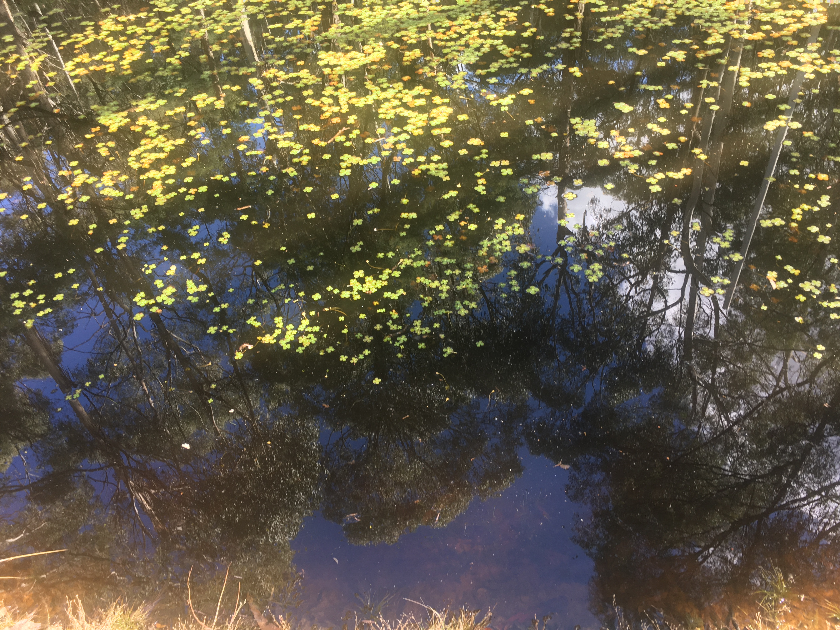
The real world. I grew into a life in a walled box of an apartment with sole parenthood and chronic illness. On quiet nights when my 10-year-old slept over at his grandmother’s house, I brought home strangers who thought they knew me from my words online and let them fuck me, delighting in a sense of power over them, idly wondering if they were fucking me for the online version of who they thought I was from what they read of me on the internet.
“You know, you barely speak during sex…”
“But I say all the things I want online.”
Offline I wasn’t always quite sure if people wanted me to exist, and so I stayed online nearly every waking moment, scrolling endless posts, watching a broken world of disease and filth and joy and mockery and kittens and rumour. When the videos from Wuhan began to appear in February 2020, I couldn’t shimmy my way through the information overload of pictures of queues at the hospitals and the people falling down dead in the streets. Hoax? Real? I hedged my bets and said almost nothing publicly.
February ticked past and then Wuhan shut down. I set a watch on epidemiologists on social media, beginning to track reports of a disease the world had never seen before. I considered making a fuss, trying to second guess myself: “If I say something and it’s nothing, then I’ll be spreading bullshit as well, and people follow me because they trust me and…” People trusted me but I didn’t know what to trust anymore.
“…I don’t know what I should do,” I said.
“You just want to bleed for these people. These strangers. So they’ll want you. They’ll suck you dry,” said my friend, goddamn her. “They only think you’re someone worth knowing online when you do things that make them think you know more than them,” she said, goddamn her. “The internet isn’t the real world,” she said, goddamn her. “Get off the couch, go for a walk,” she said, goddamn her. “People online aren’t real friends,” she said, goddamn her. “It’s not a real job, pounding the keyboard, being paid to exist on the internet,” she said, goddamn her. “All those hours, staring at a screen. You’re missing out on life, you’d be happier if you logged off,” she said, goddamn her.
“I think there’s a pandemic coming…” I said.
“You need to get a real life,” she said, goddamn her.
“You should stock up on canned food," I said.
And she laughed, because she’d never had to scrabble for anything before except a seat on the cross-fit machine at peak time at the gym.
But the fear ate me despite her laughter, and so I took my son out of school on Friday the 13th of March and left the city, uncertain if I was insane or a digital sooth-sayer, and sought safe harbour from the disease at an elderly aunt and uncle’s remote country property.
The pandemic my sources predicted arrived. School let out for everyone. The offices shut. The 7pm news showed mass graves, and my Twitter feed filled with pharmaceutical charlatans spruiking quick fixes and black market medication. I put on woolly socks to fend off the cold. I tried to learn to bake sourdough bread, conserve toilet paper and play board games with family.
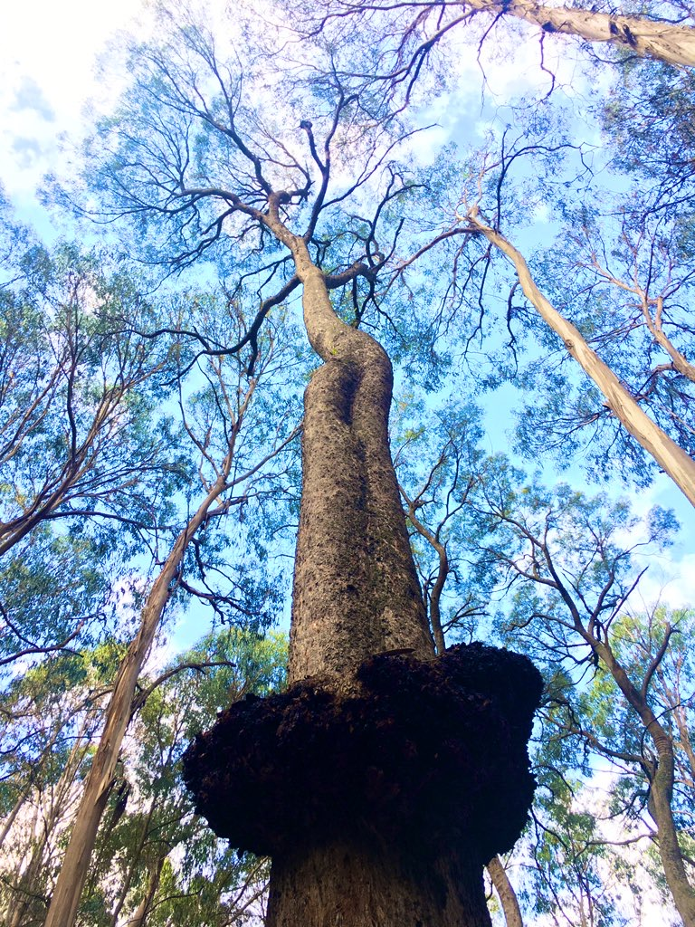
A wallaby fence loomed around the edges of the property. The floor of the house was hard-packed mud, walls rendered with cow pats and cornflower. Cold and large, heated only by log fires. The house had a single satellite internet connection. The only place I could get a stable connection was in a single corner of the living room.
After a few hours slowly going out of my mind constantly surrounded by family, I slid out of the house and into the forest that bordered the back of the property, wondering: what if the world I knew fell away? What if all the digital skills I’d spent a lifetime honing were now useless in this chaotic world? Perhaps I should’ve spent my youth learning to skin wombats and divine water sources using a forked stick? What if my network of internet followers collapsed and failed me? What if I was now just this solitary thing alone in turbulence and uncertainty, trapped in the coldness of my family’s home, surrounded by the remote forest and frozen within the confines of my own body’s illness and limitations?
So I stumbled through the forest, hoping for connection, awe, for something larger than myself. That sense of belonging to something. That gasp of amazement at the beauty and horror and completeness of everything at once. Extrasentience. A feeling of being part of something larger than myself. The same feelings I sought online being part of a swarm of a campaign or sharing ideas with so many others for so many years.
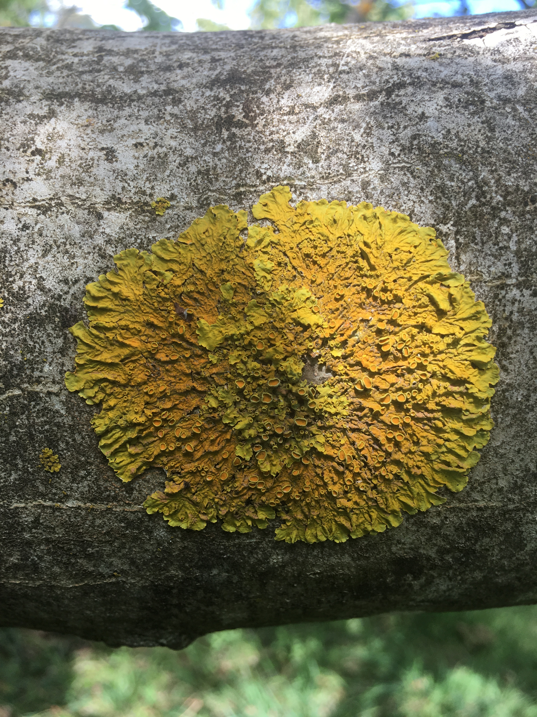
Underneath the reaching canopy formed by giant form of trees, the bright light scattered below: moss spreading across bark, mushrooms sprouting in decay on leaf litter, forest reflected in a pool of water. Tripping on the connectedness of a network reliant upon itself.
I was completely alone in the deep green of this patch of wilderness, barely capable of meandering through this space without accidentally falling down a ditch or getting lost or hitting my head on a tree branch. Useless.
So I sat on the forest floor, quiet and still amongst the wet undergrowth, my fingers fumbling with sticks and pieces of fallen wood, amusing myself and whiling away my time, examining the form and images in the curves of wood, trying to quieten the panic. If I disappeared from the internet, what dried-out relics would I leave behind? Words and images for someone else to discover and play with, perhaps? Maybe my husk of a digital presence will inspire… what? Something for a different generation to grow upon, fertilising ground for new grassroots? Or maybe nothing, just something to fall away.
I’m scared of not meaning anything to anyone, of the turmoil and pain not being worth…something. Scared that it just flows out as a thousand hours slip away, meaningless as the chaos of disease and the swirl of human conflict, never quite sure if the energy I pour into being worthwhile makes anything better, terrified of falling apart. And, most of all, the fear of not having a distraction, no longer able to poke the wound of humanity’s horrors to provoke an audience online or to arouse my own emotions.
I was never afraid of bleeding for myself or for an audience. It was always done with a purpose of flowing into something else, a connection with the world around me.
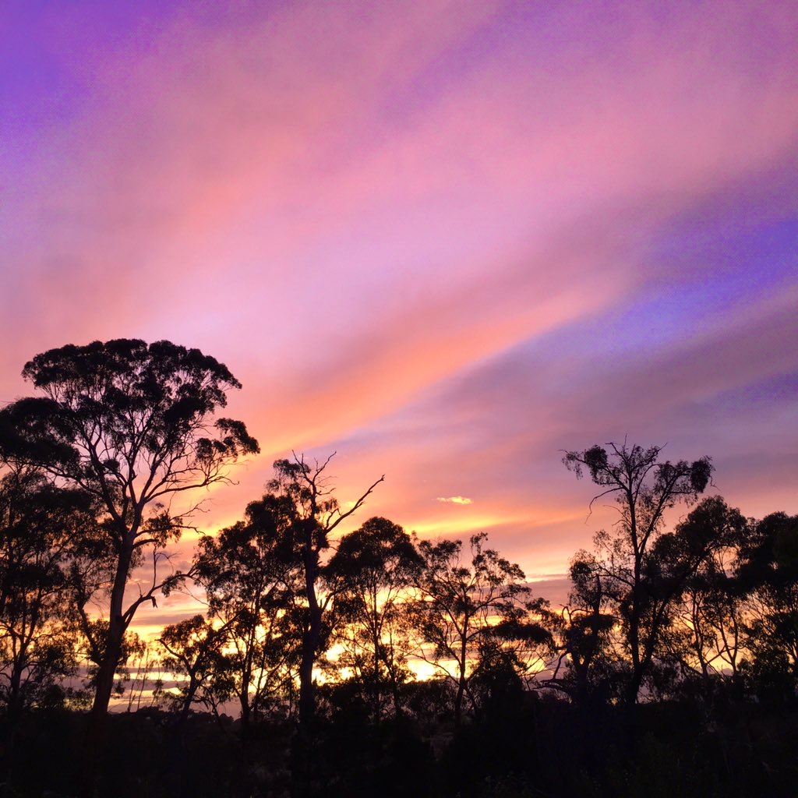
I sat surrounded by forest, the sunset spreading like fire across the sky before me, blue seeping into orange and pinks.
I stumbled out before the last light disappeared to find the internet was waiting for me: a bulky parcel gift in the post, a package filled with cords and wires and a plastic box. A repeater, to seek out a signal.
This Witness Performance essay was commissioned by Arts House, City of Melbourne and Campbelltown Arts Centre and forms part of BLEED 2020, presented in partnership with Campbelltown Arts Centre. All photographs courtesy of the author Asher Wolf.

